**Design Documentation**

**Concept Document:**

**Genre:**

* Arcade, at most, an arcade game with stage progression. Basically, it could be what a multiplayer mode or mini-game would be like in most other games. It is a game that involves a player and up to several CPU opponents. They move around a field, picking up items and using them to defeat each other in order to win. The items have an immediate effect on the game and are not “held” by any player. Each player has 3 HP (Hit Points) and is out when they are hurt three times. The winner is simply the last one standing.

**Audience:**

* This game is intended for all audiences. There is no blood or gore despite the concept. The game will be run with Processing generated shapes and possibly simple graphics.

**Competitive Analysis**

It is not very unique, as it takes the “obtaining items in a field” from many other games. This includes most multiplayer games that allow one to collect items to shoot or kill opponents. One of these is something like the battle modes of any of the Mario Kart series. The main Balloon battle present in all versions of the mode involve driving your vehicle (usually a racing kart) over to some item boxes to obtain items and use them to harm the opponents. The winner either is determined by points or is the last one standing, depending on the game. The game this is closest in design to however, is Bomberman. The Bomberman battle modes are a multiplayer game where up to four Bombermen lay down bombs, break walls, and collect items in an effort to kill each other. The last one standing wins. The current design for this game basically works in a crude fashion to the Bomberman games, where they were mostly also grid-based (though the characters themselves don’t move on a per-tile basis) with basically the same win conditions.

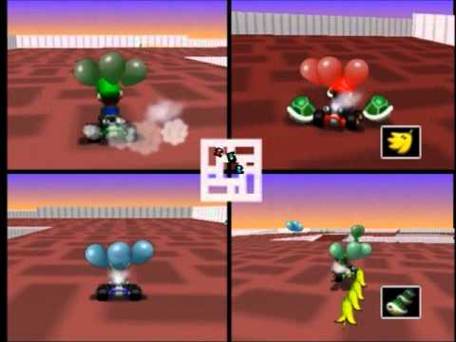

Above: Screenshot of a battle from Mario Kart 64. Balloons served as health and items are in the black boxes.

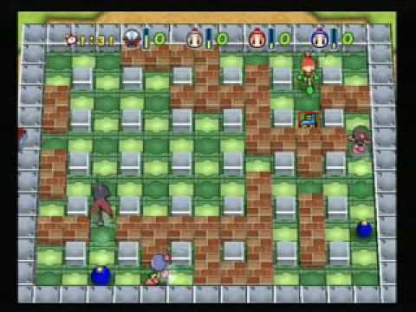

Above: Screenshot from the battle mode of Bomberman Jetters. Bombs are the blue objects, items are in panels such as the shoe in the top right, and the blocks on the field serve as obstacles. Note that in this installment, all the players were not identical to each other.

**Design Document**

Overall, this game takes many elements from the TileWorld program from earlier in the semester.

-----**Game Mechanics**-----

|  |  |  |  |  |  |  |  |
| --- | --- | --- | --- | --- | --- | --- | --- |
|  | Beam Item |  |  |  |  |  |  |
|  |  |  |  |  |  |  |  |
|  |  |  |  |  |  |  |  |
|  |  |  |  |  |  |  |  |
|  |  |  |  | ATK UP Item |  |  |  |
|  |  |  |  |  |  |  |  |
|  |  |  |  |  |  |  |  |
|  |  |  | Other Item |  |  |  |  |

Basic concept of the game layout. Player represented by the stick figure, CPU by the triangles, Items by the text, and obstacles by the gray boxes.

The field is as pictured above, a basic grid where the characters can move anywhere as long as it is not off the board. There is no “falling off the board.” The base map will not loop. The player’s positions are randomized at the beginning of the game.

Controls:

* UP, DOWN, LEFT, and RIGHT. That is all there is.

Movement:

* Movement is restricted to the four cardinal directions, and the player and all agents are able to move anywhere on the field as long as there are no obstacles on it.

How to damage opponents?

* Contact with opposing players does NOT harm either player. Players can pass through each other.
* Use of items that spawn on the field should affect the field in various ways, from creating a trap, to shooting a bullet. ETC.
* **Draft:** Players in the field can have a base attack they can use at the press of a button. In the AI’s case, either randomly or when they might hit another player. Implemented only with extra time.

How to avoid being damaged?

* **Draft:** Implement a “flash” on a tile before the attack actually hits it. This way, the player can tell where to avoid and the AI can attempt to escape the area (possibly flagged).

How to collect items?

* Several items start on the field from the beginning. Others spawn constantly over the course of the game.
* Run into them. You’ll pick them up and take their current position.

Difficulty levels:---**Draft:**--- Only Implemented as an extra if the base game is completed.

* Difficulty is increased as you win games. More AI opponents should be present on higher difficulties. If possible, increase the difficulty of the AI itself. If difficulty levels are present, then the field can also vary allowing variety in the strategies to win. EX: A field with two players sectioned off from each other.

-----**Artificial Intelligence**-----

AI should have two basic functions to reach one priority goal.

Goal: Kill the player (and all other AI in a multiple CPU game)

Functions: Seek: Look for items that can provide the AI an advantage in the game.

Avoid: Avoid possible danger zones where the AI could get hit.

Agents should be limited to a certain speed so that they cannot just out-speed everything. (If I could even program that.) This implementation is different depending on if the game world is tile based or not.

There is no AI for the game world. The game environment itself should not change other than the items that spawn.

-----**Game Elements**-----

Characters:

* 1 Player and up to 3 CPU opponents, 3 lives each. There are no distinct characters as the game involves up to four players that should start on equal footing. They only have the capabilities to move on the field.

Objects:

* Obstacles should be present to prevent the field from being a completely blank slate.
* Dangerous tiles where any player could be harmed.

Items:  
**--Draft—Subject to a large amount of changes. Would have to be able to implement graphics to make this more complete and complex. Most items should be the type that deals damage.**

* ATK Up: Increase power to be able to do 2 damage to an opponent for either: 1-The next item used. 2- A limited amount of time.
* SPD Up: Increases movement speed of AI agents. Speeds up max possible speed for player. This is likely not to be stackable or permanent.
* Barrier: Nullify damage for one hit for a limited amount of time.
* Invincibility: Nullify all damage for a limited amount of time.
* HP Recovery: Restores health. Should be used sparingly if at all.
* Energy Bullet: Shoots four dots around you that damage on contact. Should be able to pass through obstacles.
* Shockwave: Damages all players other than the user in a 4x4 area. Is not affected by obstacles.
* Lightning: Something that hits a 3X3 area randomly on the field.
* A Curse Item: Causes negative status effects to the player that grabbed it. Should be disguised as another item to prevent everyone avoiding it. AI will still seek it.

Sample Item Panel:

**Story**

**Draft:** Currently, the characters have absolutely no backstory. At best, this is going to have a pointless one, as gameplay has nothing to do with them. Maybe, some character participates in a tournament to reach the top and beat the champion. This kind of story only applies if difficulty levels are implemented. Otherwise, this is a virtual sport and the players are all participants in it.

**Development Schedule**

* April 21- Concept Document Due.
* April 22- Work begins on project.
  + - Testing happens constantly during development. There is no designated development or testing phase. They happen concurrently to ensure there are NO unknown errors later on.
* May 12- Basic Implementation Due.
  + - A working game is due at this point. Additional features may still be implemented, but this should be the point where the base game works.
* May 17- Final Implementation Due.